**Zhenhua Yang**

/**

* home assignment 5 Programming Exercises_1

* @author aaronyang

*/

public class UnicodeTable {

public static void main( String [] args )

{

int value = 32; // create value variable with the default value of 32

char charValue; // create charValue to save the Character associated with value.

// print the top boarder of the table

System.out.println("_____________________________________________________" +

"______________________________________");

System.out.print("|");

// print the header of the table

for( int i = 0; i < 5; i++ )

{

System.out.printf( "%6s |%6s |", "Value", "Char" );

}

// print the horizantal lines of the table

System.out.println();

System.out.println("----------------------------------------------------" +

"---------------------------------------");

// for loop to print each value and charValue

for( int i = 0; i < (128-32)/5; i++ )

{

for( int j = 0; j < 5; j++ ) // nested for loop printing five values and charValues per line

{

charValue = (char)value;

System.out.printf( "%6s %6s ", value, charValue );

value ++;

} // end nested for loop

// print the horizantal lines of the table

System.out.println("\n-----------------------------------------------------" +

"--------------------------------------");

} // end outer for loop

}

}

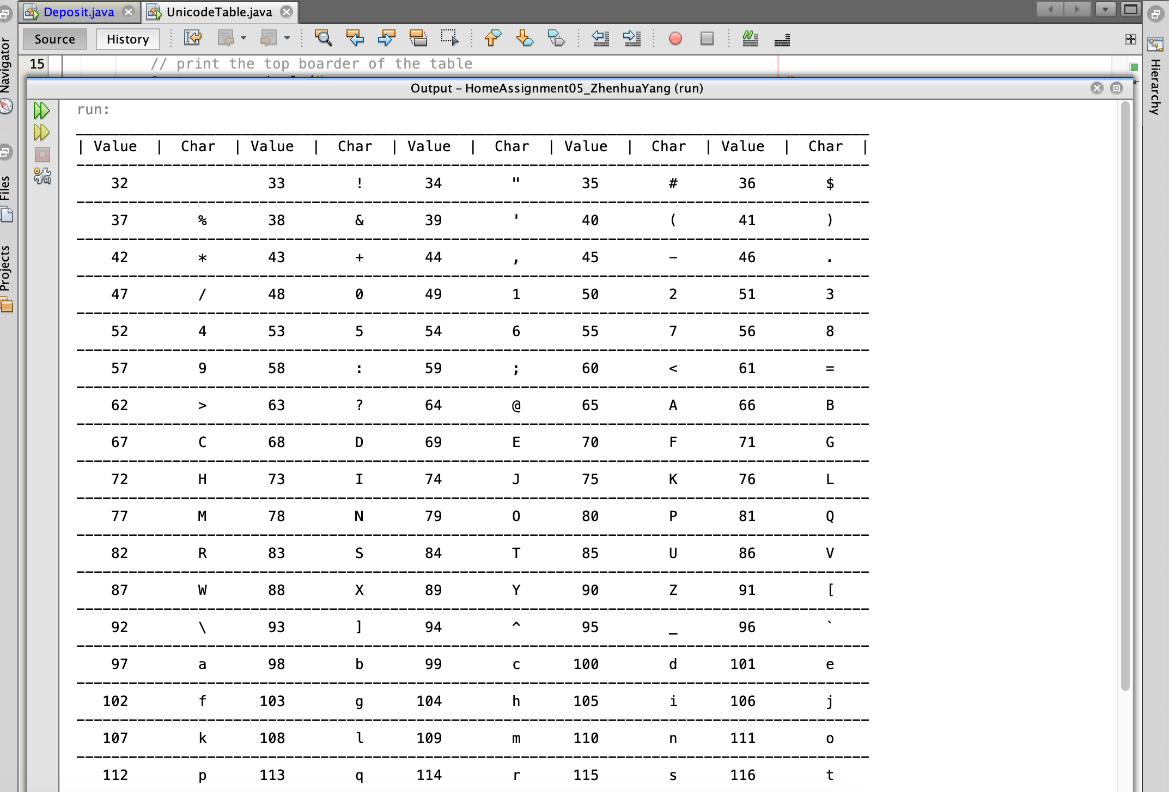

import java.util.Scanner;

import java.text.DecimalFormat;

public class Deposit

{

public static void main( String [] args )

{

// Create viariables

final double INT = .1;

double total = 0;

int year;

double initialAmount;

// Instantiate Scanner object

Scanner input = new Scanner( System.in );

// Start do...while loop

do {

System.out.println( "Please enter following data or -1 to exit \n");

// Ask user to enter initial amount

System.out.print("Please enter your initial amount:> ");

initialAmount = input.nextDouble();

// exit case

if( initialAmount == -1 )

{

System.out.println("\n==Thank you for using this app. Bye.==\n");

break;

}

// Ask user to enter the number of years

System.out.print("How many years do you want to save? > ");

year = input.nextInt();

// exit case

if( year == -1 )

{

System.out.println("\n==Thank you for using this app. Bye.==\n");

break;

}

// create the DecimalFormat object.

DecimalFormat decimal = new DecimalFormat("#.##");

// calculate the total amount of money over the number of years user entered

total = initialAmount * Math.pow( (1 + INT), year );

// print the total balance

System.out.println("The total balance at the end is: " + decimal.format(total) );

// the total balance at year + 1

double total2 = initialAmount * Math.pow( ( 1 + INT ), year + 1 );

// the monthly income after 61 years old.

double monthlyIncome = (((INT / 12) * total2) / ( 1 - ( Math.pow ( 1 / (1 + INT), 12 * year))));

System.out.println("\nThe total balance after " + (year + 1) + " years is: "

+ decimal.format(total2)

+ "\nThe interest earned during this year is " + decimal.format(total * INT)

+ "\nMonthly income is " + decimal.format(monthlyIncome)

+ "\n *** \n");

} while ( initialAmount !=-1 ); // end while loop

}

}

You decide to leave the money in the IRA for another year. Starting from your 61st birthday, you decide to withdraw each year’s interest income. In other words, you withdraw the interest and leave the rest of the money untouched. How much income would you have per month for the rest of your life?

**If the initial investment was $1700, the monthly income would be $1032.62;**

**If the initial investment was $3600, the monthly income would be $2186.71;**

**If the initial investment was $8500, the monthly income would be $5163.08;**

The initial investment was $___**1700**____. The total amount accumulated after __**44**__ years, if $__**1700**__ is allowed to compound with an interest rate of 10.00%, comes to $_**112648.93**_.

The total amount accumulated after __**45**__ (years + 1) years, if $__**112648.93**__ is allowed to compound with interest rate of 10%, comes to $_**123913.82**_.

The interest earned during this year is $__ **11264.89**__. If interest is withdrawn each year thereafter, my income is $_ **1032.62**_ per month.

The initial investment was $__**3600**_. The total amount accumulated after _**44**_ years, if $_**3600**_ is allowed to compound with an interest rate of 10.00%, comes to $__**238550.67**__.

The total amount accumulated after _**45**_(years + 1) years, if $_**238550.67**_ is allowed to compound with interest rate of 10%, comes to $__**262405.74**_.

The interest earned during this year is $_**23855.07**_. If interest is withdrawn each year thereafter, my income is $__**2186.71**__ per month.

The initial investment was $__**8500**_. The total amount accumulated after _**44**_ years, if $_**8500**_ is allowed to compound with an interest rate of 10.00%, comes to $_**563244.65**_.

The total amount accumulated after _**45**_ (years + 1) years, if $_**563244.65**_ is allowed to compound with interest rate of 10%, comes to $__**619569.11**_.

The interest earned during this year is $_**56324.46**_. If interest is withdrawn each year thereafter, my income is $_**5163.08**_ per month.

